Project Planning Phase
Project Planning Template (Product Backlog, Sprint Planning, Stories, Story points)

Date | 27 June 2025
Team ID | LTVIP2025TMID36160
Project Name | Citizen AI – Intelligent Citizen Engagement Platform
Maximum Marks | 5 Marks

Product Backlog, Sprint Schedule, and Estimation (4 Marks)
Use the template below to create a product backlog and a sprint schedule
Sprint | Functional  Requirement (Epic) | User Story Number | User Story / Task | Story Points | Priority | Team  Members
Sprint-1 | Registration | USN-1 | As a user, I can register for the application by entering my email, password, and confirming my password. | 2 | High | Dev-1, QA-1  Backend Dev,  UI Dev
Sprint-1 | Registration | USN-2 | As a user, I will receive a confirmation email once I have registered for the application | 1 | High | Dev-1  Backend Dev
Sprint-2 | Registration | USN-3 | As a user, I can register for the application through Facebook | 2 | Low | Dev-2  Full Stack Dev
Sprint-1 | Registration | USN-4 | As a user, I can register for the application through Gmail | 2 | Medium | Dev-2  Full Stack Dev
Sprint-1 | Login | USN-5 | As a user, I can log into the application by entering my email & password | 1 | High | Dev-1  Backend Dev
Sprint-1 | Dashboard | USW-3 | As a web user, I can submit feedback on any public service through a text form | 3 | High | Dev-2, QA-1
Sprint-1 | AI Chat Integration | USW-7 | As a web user, I can ask the chatbot questions related to government services | 4 | High | Dev-3 (API), Dev-1 (Flask
Sprint-1 | Sentiment Storage & API Integration | USW-5 | As a user, I can view my sentiment submission history on a timeline | 2 | Medium | Dev-3

Project Tracker, Velocity & Burndown Chart: (4 Marks)
Sprint | Total Story Points | Duration | Sprint Start Date | Sprint End Date (Planned) | Story Points  Completed (as on  Planned End Date) | Sprint Release Date (Actual)
Sprint-1 | 20 | 6 Days | 24 Oct 2022 | 29 Oct 2022 | 20 | 29 Oct 2022
Sprint-2 | 20 | 6 Days | 31 Oct 2022 | 05 Nov 2022 | 20 | 05 Nov 2022
Sprint-3 | 20 | 6 Days | 07 Nov 2022 | 12 Nov 2022 | 19 | 12 Nov 2022
Sprint-4 | 20 | 6 Days | 14 Nov 2022 | 19 Nov 2022 | 18 | 19 Nov 2022
Sprint-5 | 20 | 6 Days | 21 Nov 2022 | 26 Nov 2022 | 20 | 26 Nov 2022
Sprint-6 | 20 | 6 Days | 28 Nov 2022 | 03 Dec 2022 | 19 | 03 Dec 2022
Sprint-7 | 20 | 6 Days | 05 Dec 2022 | 10 Dec 2022 | 20 | 10 Dec 2022
Sprint-8 | 20 | 6 Days | 12 Dec 2022 | 17 Dec 2022 | 19 | 17 Dec 2022

Velocity:
Imagine we have a 10-day sprint duration, and the velocity of the team is 20 (points per sprint). Let’s calculate the team’s average velocity (AV) per iteration unit (story points per day)
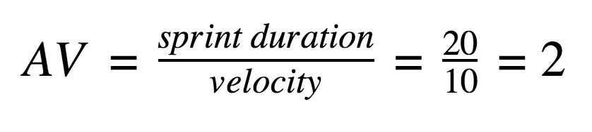

Burndown Chart:
A burndown chart is a visual tool used in Agile project management to track work remaining versus time. It shows how much work is left (usually in story points) on the vertical axis and time (sprint days) on the horizontal axis. The chart helps teams monitor progress and predict whether project goals will be met on time. It typically includes an ideal progress line and an actual progress line. Burndown charts promote transparency and early identification of delays or scope issues.
The ideal progress line represents the planned pace of work completion, providing a benchmark for the team. The actual progress line reflects real-time updates on how the team is performing against that plan. When the actual line is above the ideal, it may indicate delays; when below, the team is ahead of schedule. By reviewing the chart daily, teams can adapt their strategies, redistribute tasks, or address blockers promptly. Overall, burndown charts support continuous improvement and help ensure the timely delivery of project outcomes in an agile environment.
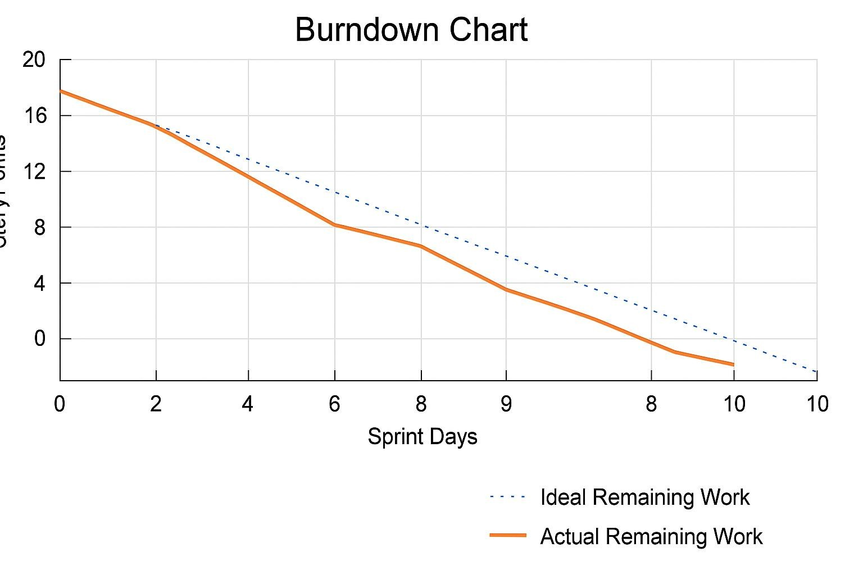
The Burndown Chart illustrates sprint progress over 10 days, tracking the decrease in story points from 20 to 0.
- X-Axis: Sprint Days (0–10)
- Y-Axis: Story Points (Work Remaining)

It includes two lines:
- Dotted Blue Line: Ideal progress path (consistent linear drop)
- Solid Orange Line: Actual progress made by the team (slower at mid-sprint, caught up near the end)

Key Insights:
- Days 1–3: Progress close to ideal, slight variance
- Days 4–6: Noticeable slowdown — actual line dips below ideal
- Days 7–10: Team accelerates, catching up to finish near the target

Outcome: Sprint completed with nearly all work delivered, despite minor mid-sprint delays
Conclusion: A realistic and healthy burndown pattern, indicating solid team effort and adaptive sprint execution.

